**How to update Google Maps**

1. Go to <https://www.google.com/maps>

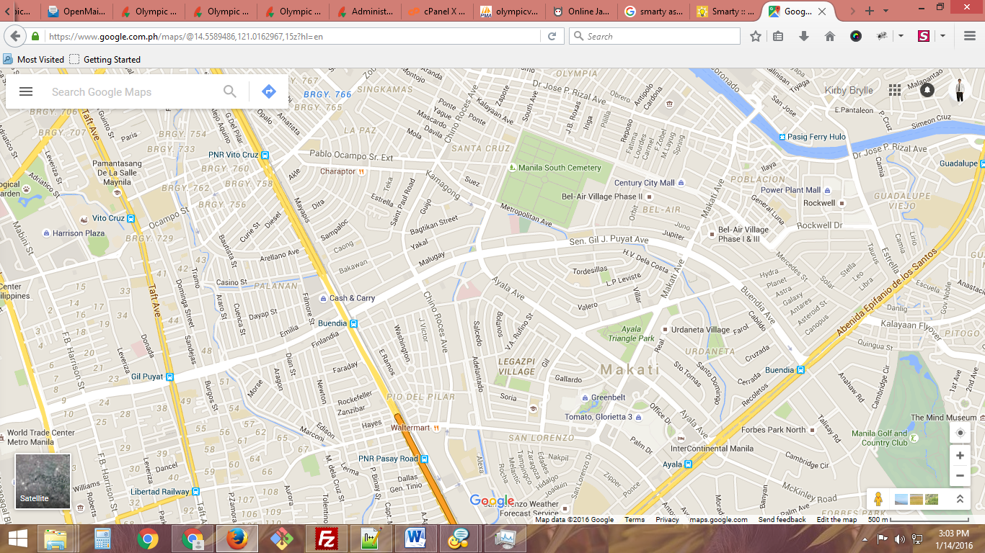

2. Locate your target area

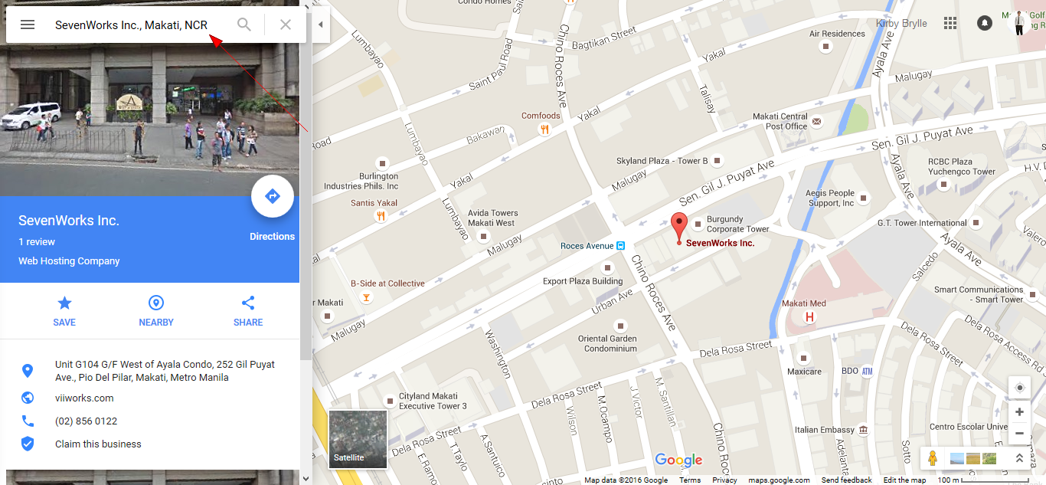

3. Click the **Menu** button in the top left found in the page.

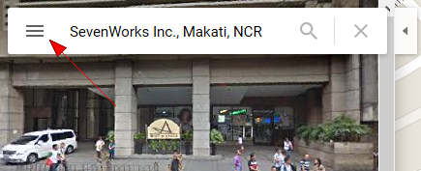

4. Click **Share or embed map**.

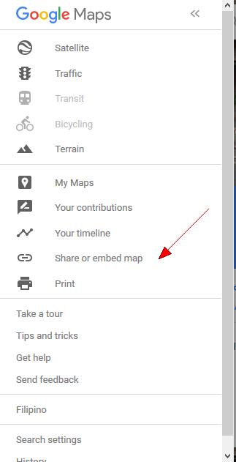

5. A popup modal will appear. Click **Embed map**.

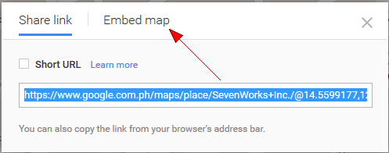

6. **Copy** the iframe link.

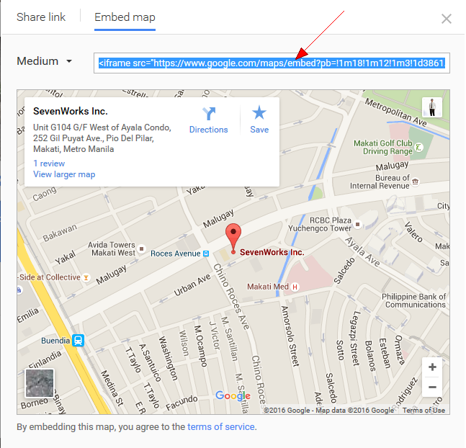

7. Login as **admin** (admin/test or webadmin/7works).

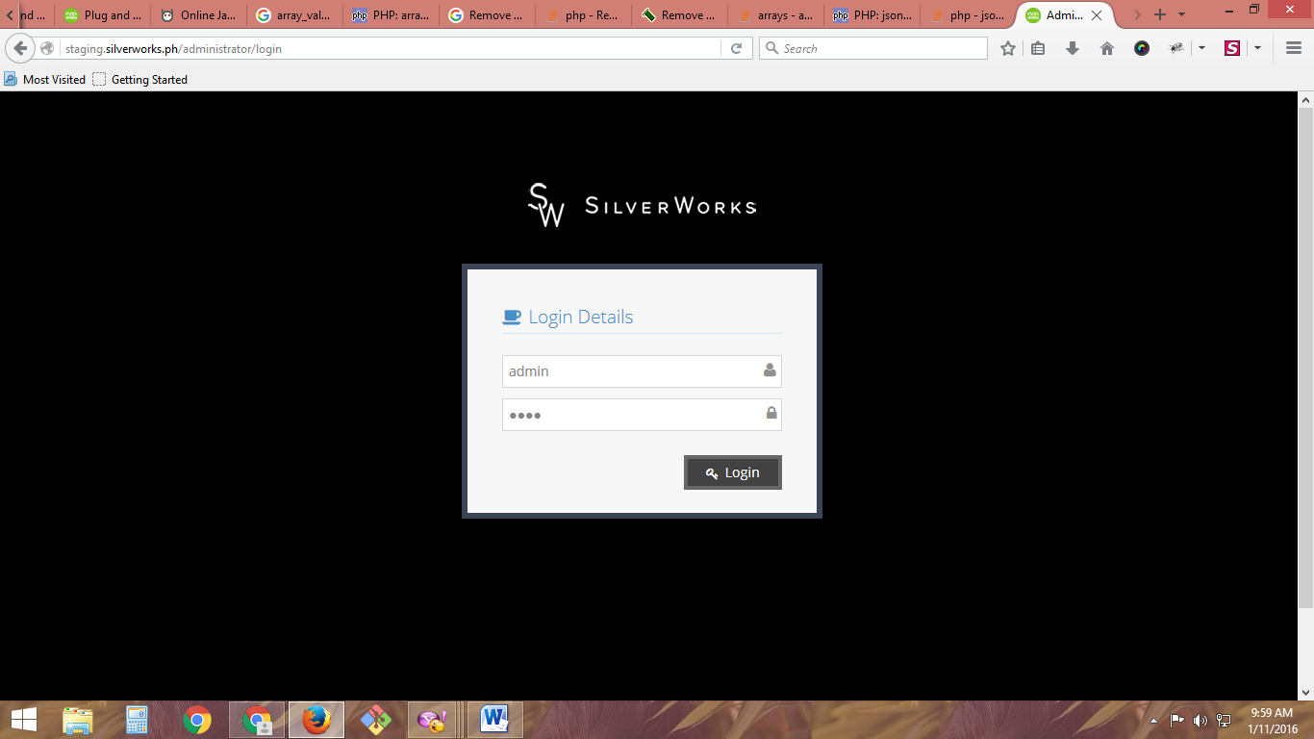

8. Click **Contact Us**.

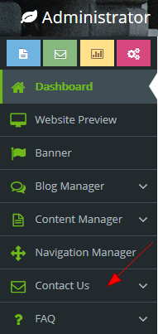

9. Click **Settings**.

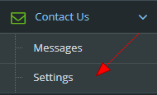

10. Click **Edit**.

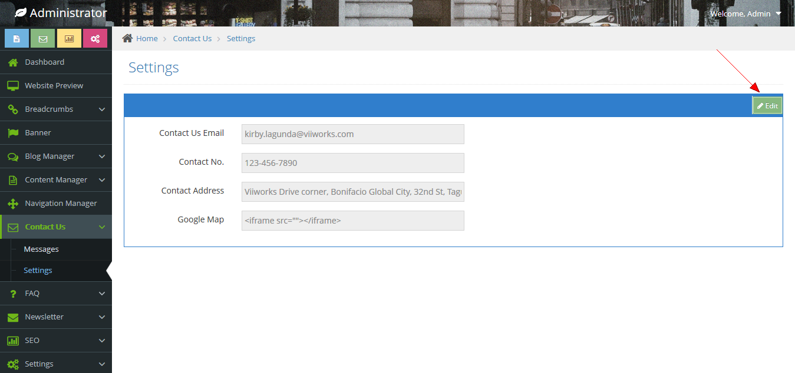

11. **Paste** the copied link and submit.

